Intellectus**Press**



***How to Write and Publish a Scientific Paper: Key Insights for Effective Scientific Communication***

***Como Escrever e Publicar um Artigo Científico: Principais Percepções para uma Comunicação Científica Eficaz***



**Short Comunication**

Isaac Newton1; Isaac Newton1

*1University of Cambridge, Faculty of Mathematics, United Kingdom; 2ETH Zurich, Department of Physics, Switzerland2; Filiation of Author3…*

Corresponding author: Isaac Newton (isaac.newton@cambridge.edu).

DOI: 10.1234/XXXXXXXXXXXXXX

**Received** xx February 2024 - **Accepted** xx March 2024 - **Published** xx November 2024

**Abstract**

Scientific writing is a cornerstone of academic communication. How to Write and Publish a Scientific Paper provides foundational principles to guide researchers in structuring and presenting their findings. This short communication highlights the critical aspects of the book, emphasizing its relevance for early-career researchers. Key insights include the importance of clarity, adherence to the IMRAD format, and balancing creativity with academic rigor. The challenges of writing for a global audience and addressing linguistic barriers are also discussed.

**Resumo**

A escrita científica é a base da comunicação acadêmica. Como Escrever e Publicar um Artigo Científico fornece princípios fundamentais para orientar pesquisadores na estruturação e apresentação de seus achados. Esta comunicação breve destaca os aspectos críticos do livro, enfatizando sua relevância para pesquisadores iniciantes. Percepções principais incluem a importância da clareza, da adesão ao formato IMRAD e do equilíbrio entre criatividade e rigor acadêmico. Também são discutidos os desafios de escrever para um público global e de lidar com barreiras linguísticas.

## **Keywords:** science; ethics; sustainability; education; cooperation.

**1. Introduction**

Effective scientific writing is essential for disseminating research findings and advancing knowledge. The book How to Write and Publish a Scientific Paper by Day and Gastel serves as a comprehensive guide for researchers navigating the complex process of scientific publication. This communication explores the book's key contributions, addressing its strengths and areas for further enhancement [1-3]

**2. Main Discussion**

The book underscores the value of adhering to the IMRAD structure (Introduction, Methods, Results, and Discussion), which fosters clarity and replicability in scientific papers. Early-career researchers benefit from its step-by-step guidance on crafting abstracts, writing clear methods, and presenting results effectively. However, one notable limitation is the lack of focus on adapting writing styles for diverse cultural and linguistic audiences. As English remains the dominant language of science, researchers from non-English-speaking backgrounds face significant challenges. Incorporating strategies to overcome these barriers would make the book more inclusive (Figure 1). Additionally, the emphasis on formal structure occasionally overshadows the need for creativity and innovation in presenting scientific findings[4].

**Figura 1-** Book cover

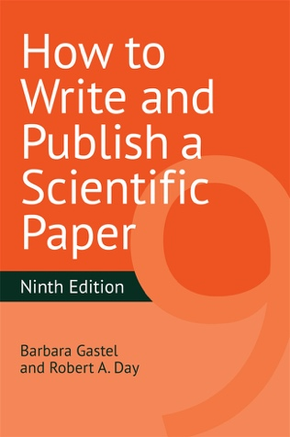

Legend: Ninth edition of “How to Write and Publish a Scientific Article”

**3. Conclusion**

How to Write and Publish a Scientific Paper remains an invaluable resource for scientists. By addressing inclusivity and fostering a balance between standardization and creativity, future editions can better meet the needs of a diverse, global audience[5].

**4. References**

[1] Day RA, Gastel B. How to write and publish a scientific paper. 7th ed. Cambridge University Press; 2011.

[2] Swales JM, Feak CB. Academic writing for graduate students: essential tasks and skills. 3rd ed. University of Michigan Press; 2012.

[3] Peh WC, Ng KH. Basic structure and types of scientific papers. Singapore Med J. 2008;49(7):522-8.

[4] Hall GM. How to write a paper. 5th ed. Wiley-Blackwell; 2013.

[5] ICMJE. Recommendations for the conduct, reporting, editing, and publication of scholarly work in medical journals. Available from: https://www.icmje.org.